South DeKalb Improvement Association
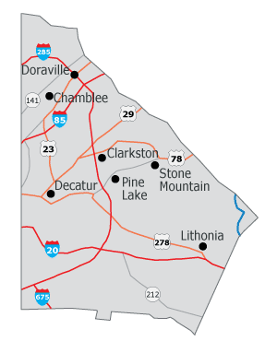
Membership Application Form

LAST NAME:__________________________FIRST:__________________________M.I._______
ADDRESS:_____________________________________________________________________
CITY:____________________________STATE:__________________ZIP:__________________
BIRTHDAY:___/___/____ TELEPHONE: (H/W/M) (____)_______________________________
EMAIL ADDRESS:_______________________________________________________________
TYPE OF MEMBERSHIP: PLEASE CHECK ONE. [ ] NEW MEMBER* [ ] RENEWAL
NEW MEMBER REFERRED BY:_____________________________________________________
FEES: INDIVIDUAL ($10) HOA:__________________________________NO HOA ($20)_______
HOA MEMBERSHIP <50 ($100) >50 ($150) HOA must be a member to get reduced fees.
Please make checks payable to: South DeKalb Improvement Association, and mail with this application form to: SDIA, P.O. Box 361050, Decatur, GA 30034
AREAS OF INTEREST:
BUSINESS MEMBERSHIP $50
Company/Business Name
______________________________________________
Type of Service_________________________________
Address_______________________________________
City/State/Zip__________________________________
Tel#________________ Fax #_____________________
Email Address__________________________________
Website_______________________________________
PLEASE CHECK ONE
[ ] | HOUSING
[ ] | CODE ENFORCEMENT
[ ] | EDUCATION
[ ] | ECONOMIC DEVELOPMENT
[ ] | SAFETY
[ ] | MEMBERSHIP
[ ] | FUND RAISING
[ ] | NEWSLETTER
[ ] | HEALTH
[ ] | SPECIAL PROJECTS

Date Approved:____________________ Date Accepted:________________ Amount Paid: $________

